Short Term Scientific Missions (STSMs) & Virtual-Mobility Grants (VMGs):
Open call for applications
8 February 2022
Short Term Scientific Missions (STSMs) and Virtual Mobility Grants (VMGs) represent excellent opportunities not only to achieve the goals of the EUdaphobase COST Action, but also for researchers to network with one another throughout Europe.
STSMs are a networking tool for physical collaboration of an individual researcher in an institution of a different country. VMGs allow networking of individuals or smaller teams in a virtual environment (providing collaboration possibilities despite the limitations of the pandemic).
We hereby call for applications for Short Term Scientific Missions and Virtual Mobility Grants.
Eligible to submit STSM/VMG applications are individuals with a primary affiliation to a “legal entity” (= institution) located in a COST Full or Cooperating Member country, a COST Near Neighbour Country or a European RTD Organisation. Being a EUdaphobase participant is not a requirement!
Any topic related to the Action’s objectives is eligible for consideration. The primary requirement is that applications focus on fulfilling the goals of the current EUdaphobase Grant Period (see Annex 1). In the current Grant Period, a number of topics are suggested (see Annex 2), for which applications are now explicitly called for and which will be given priority. Nonetheless, applications concerning any topic benefitting the EUdaphobase Action or the data infrastructure are welcome.
Both STSMs and VMGs are financed via grants. STSM grants are divided into travel costs and subsistence (accommodation, meals, local travel), up to a maximum of 4000 € (depending on the STSM duration and location of the host institute; average ca. 2000 €). VMG grantees can receive a grant of max. 1500 €. Both are a lump-sum payment and thus may be used in any manner by the grantee or his/her institution to meet EUdaphobase Action goals. Extra funding for purchase of software, technical equipment etc. is not possible. Payment of the Grant occurs after approval of a final report, due after the STSM/VMG grant end date, but no later than 31 Oct. 2022. Although no specific financial reporting is expected, grantees are highly recommended to retain (for up to 1 year after the end of the COST Action) any receipts and financial documents proving the targeted nature of expenditures.
Application for STSMs and VMGs are submitted via eCOST (see Annex 3) and should include:
- a main objective and goals
- a work plan
- main expected outputs (incl. how outcomes will generate benefits to the Action)
- for STSMs: a letter of invitation from a senior researcher affiliated to the Host Institution
- for VMGs: a participation plan (i.e., a list of participants in the collaborative initiative [however: the Grant is payed to only one person per VM grant! He/she may distribute funds further])
Although applications can be submitted during the entire Grant Period (“open call”), the deadline for the first round is 15 March 2022. Primary criteria for acceptance are the formal eligibility requirements (see Section 6.4 of the COST Annotated Rules [under “Other networking activities/All others”]) and how the expected outputs fulfil the goals of the current EUdaphobase Grant Period.

Annex 1
Goals of the EUdaphobase Action for the current Grant Period (01 Nov 2021 - 31 Oct. 2022)
1) Standardize and implement data-collation procedures for data throughout Europe.
2) Finalize data identification related to traits and ecosystem services; begin collating such data.
3) Ensure user-friendly interfaces for the public data-infrastructure software.
4) Identify algorithms (and the necessary data) for assessment tools.
5) Build capacity for uploading, and using, data to/in the data infrastructure.
6) Formalize the conceptual structures and procedures for a sustainable data infrastructure (e.g., ontologies, standardized vocabularies and nomenclatures).
7) Increase public awareness of the data infrastructure and its uses.

These are intended to fulfil the following EUdaphobase Action’s objectives (as detailed in the MoU):
- Create the infrastructure and knowledge network necessary for establishing an open-access, pan-European knowledge warehouse for soil biodiversity and for developing tools that use this data for assessing soil biodiversity, soil quality, soil ecosystem services and soil protection in general.
- Create an inventory of individual, institutional and national-level datasets on soil biota at the European scale as well as to develop and test easily usable data-import tools.
- Design a set of guidelines and procedures both for building capacity in data digitisation as well as for combining, harmonizing and quality controlling soil-biodiversity data.
- Develop and agree upon a data policy that sets standards and options for data sharing and re-use while guaranteeing the intellectual property rights of data providers as well as creating incentives for data sharing.
- Facilitate synthesis of ecological data across multiple groups of soil fauna and provide proxies for ecosystem services provided by soil food webs under different environmental conditions and soil types.
- Develop user-friendly interfaces to the data warehouse and its tools, addressing data provider and user needs.
- Develop models of the distribution of potential soil-biodiversity and indicators as well as of relationships with soil factors and soil-management practices that can be used in semi-automated evaluation tools.
- Build capacity and competency for digitizing and cataloguing soil-biodiversity and ecological metadata and for importing digitised data to a data warehouse.
- Increase the understanding of combining biodiversity, environmental metadata and trait information for answering questions of soil biodiversity and protection.
- Heighten the awareness of the necessity of combining soil research data in a common platform as well as to increase the sense of belonging to a soil-biodiversity data community.
- Heighten awareness of the availability of a publically available data platform and its assessment tools and of the possibility of influencing its developmental direction.
- Develop principles for data use and mapping knowledge on soil biodiversity in Europe.
- Form a board of taxonomic and ecological experts for a broad range of soil-organism taxa, which will be able to facilitate quality control for newly generated data as well as deriving the distribution and ecosystem influence of soil-dwelling species.
- Increase awareness of the general public for soils, soil biodiversity and soil ecosystem services.

Annex 2
Suggested STSM/VMG topics for the current Grant Period (01 Nov 2021 - 31 Oct. 2022)
The following topics have been suggested in the current Grant Period contract with the COST Association. Applications regarding these topics are now explicitly called for and such applications will be given priority.
Nonetheless, applications concerning any topic benefitting the EUdaphobase Action or the data infrastructure are welcome.
- Text mining, analysis of published articles regarding available soil-biodiversity data, digitizing older data (i.e. from older reports or publications), etc.
- Linking traits with ecosystem services; identification of a set of key traits (via literature research and discussions among WG3 participants)
- Collating data on, e.g., earthworm traits over Europe; comprehensive data collection, alignment and upload
- Digital guide to the key soil invertebrate traits; methodology summarisation and illustration
- Compilation of list of traits for Myriapoda; draft ontology for these traits
- Improvement of software GUIs for better usability by external users (public, stakeholders, scientists)
- Ontology development for Edaphobase data structures
- Analysis of the Edaphobase data model in regard to FAIR principles and internal & external data linkages
- Modelling epidemiological and epizootic risks associated with, e.g., oribatid mite diversity in Europe
- Procedures for soil food-web modelling based on incomplete datasets
- Developing filters for Mycobank taxonomic data to be implemented in Edaphobase
- (Microbial) Data mining of, e.g., EcoFinders results, for upload to Edaphobase
- Standardized list of molecular methods for microbial communities, to be used as data-harmonization procedures in Edaphobase
- Determination of influence of soil fauna communities on SOM decomposition, to determine key data for ecosystem services to be used in the Edaphobase data infrastructure
- Modelling mycorrhizal impact on carbon sequestration, to determine key data for ecosystem services to be used in the Edaphobase data infrastructure
Drafts of associated publications are to result from all STSMs or VMGS

Annex 3
eCOST procedure for submitting an application for
a Short Term Scientific Mission (STSM) or a Virtual Mobility Grant (VMG)
For details, please see Annex 2 (pp. 91 - 97) of the COST Annotated Rules (https://www.cost.eu/uploads/2021/10/COST-094-21-Annotated-Rules-for-COST-Actions-Level-C-2021-11-01-1.pdf).
All applications will be accessed and reviewed by the EUdaphobase Action and Working Group chairs and co-chairs, Grant Manager, Dissemination Officer and Management Committee [MC]). Approval of applications is by the MC.
For questions, please contact the EUdaphobase Grant Manager Prof. Olaf Schmidt (olaf.schmidt@ucd.ie).

Applicant and responsibilities
Eligible as applicant(s) are individual persons with a primary affiliation to an institution (= “legal entity”) located in a COST Full or Cooperating Member Country, a COST Near Neighbour Country, or a European RTD Organisation (see Section 6.4. of the COST Annotated Rules).
Applicants are not required to be EUdaphobase members, but members will be given priority.
Younger and Early Career applicants will be prioritized; but this is not a prerequisite.
The applicant(s) must state in the application the aim of the STSM/VMG and how its outcomes will generate benefits to the Action, actively contribute to the overall objectives and relevant deliverables of the Action.
Applicant(s) must submit an activity report at the latest 30 days after the end date of the STSM/VMG or by 31 Oct. 2022 (whichever is first), to be approved by the Action’s management committee (MC).
To submit a STMS or VMG application, the applicant must be registered in eCOST (https://eservices.cost.eu)

Creating a STSM or VMG application in eCOST
The applicant submits a STSM or VMG application by first logging onto e-COST and clicking on the Grant Application page (https://e-services.cost.eu/activity/grants/add).
To begin submission of a new application, the applicant clicks on ‘Continue’ for the relevant Grant type.
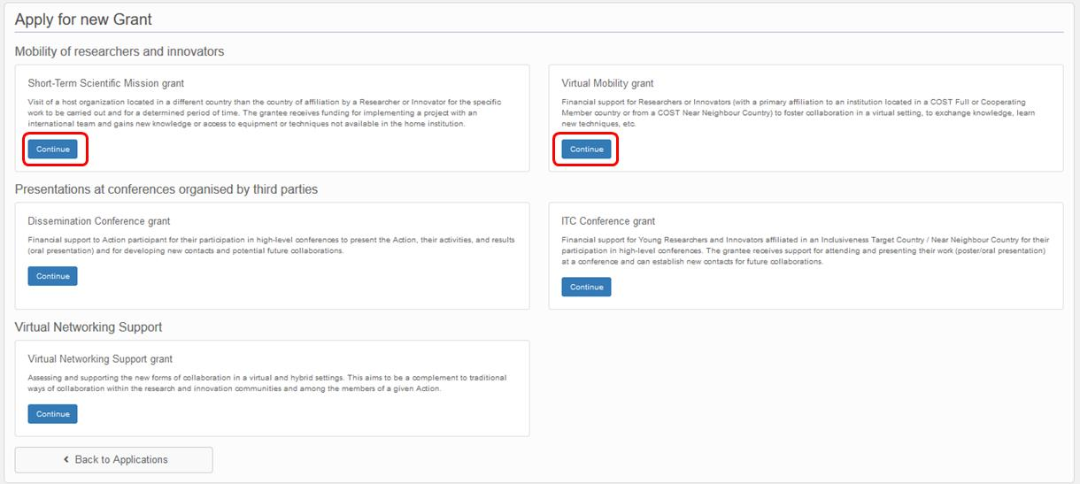

The resulting eCOST page is similar for STSMs and VMGs. The page for STSMs includes additional fields for information regarding the host institution. This page provides data fields for entering formal information, all of which are mandatory to be filled in:
- Applicant name: pre-filled (from the eCOST registration/log-in) and non-editable
- Applicant primary affiliation: pre-filled and non-editable
- COST Action: selection of the COST Action to which the application is submitted.
Enter “CA18237” and the EUdaphobase Action will automatically appear.
- Grant Period: selection of applicable Grant Period, initially pre-filled for our 3rd Grant Period.
- Title: title of the STSM/VMG application
- Amount: requested financial grant
- The maximum allowable Grant for STSMs is 4000 € per STSM and for VMG 1500 € per VMG. However, the amount of the approved grant will be dependent on the duration of the STSM/VMG, the subject material and the location (for STSMs). The maximum Grant will not be automatically approved and should only exceptionally be applied for (and justified in the supporting documents)!
- Bank account: selection among bank accounts encoded in the e-COST user profile
- Start and end dates of the STSM/VMG being applied for.
- The minimum duration is 5 days, including travel for STSMs.
- There is no maximum duration, but the STSM/VMG must be carried out within a single Grant Period (no exceptions!).
- For STSM applications: information regarding the host institution (name, city, country, website) and host person (name, e-mail address).
- For STMS: the applicant and Host institution must be in different countries.
After completing this, click “save application”, which will lead to the next Grant Application page.
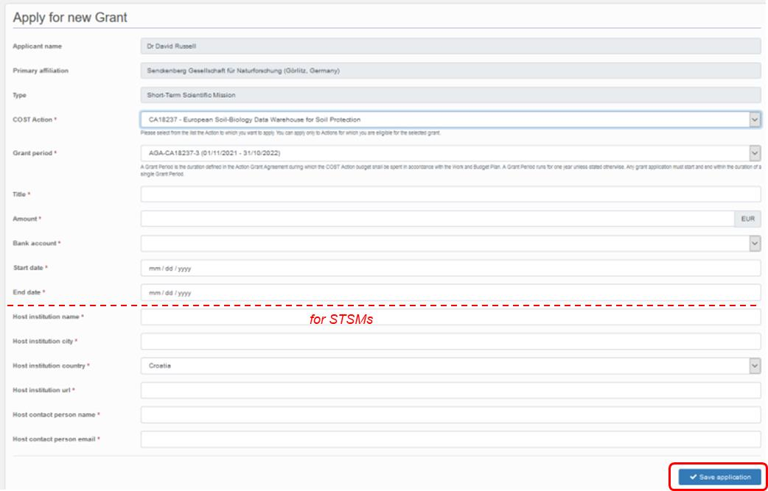

After correctly encoding the application form by filling all above-mentioned sections, the applicant must then submit the actual application by uploading it as a “supporting document” on the next eCOST Grant Application page.

The page is also similar for STSMs and VMGs, although different documents are required:
- For both STSMs and VMGs: the formal Grant Application document, which must follow the template provided by the COST association. The templates can be assessed by clicking on “Download Grant Application template”. The template is also shown at the end of this document.
- For STSMs: A confirmation / letter of invitation provided by a senior researcher affiliated to the Host Institution.
- It is recommended to also submit a short CV and/or a letter of motivation from the applicant, which can help avoid questions (and therefore delays) during the approval process.
- For students (Masters, PhD) or young researchers applying for a STSM or VMG, a letter of recommendation from the applicant’s supervisor is also highly recommended.
- Documents can be uploaded (submitted) in various file formats and be up to 2 MB in size. Uploading of multiple supporting documents is possible.

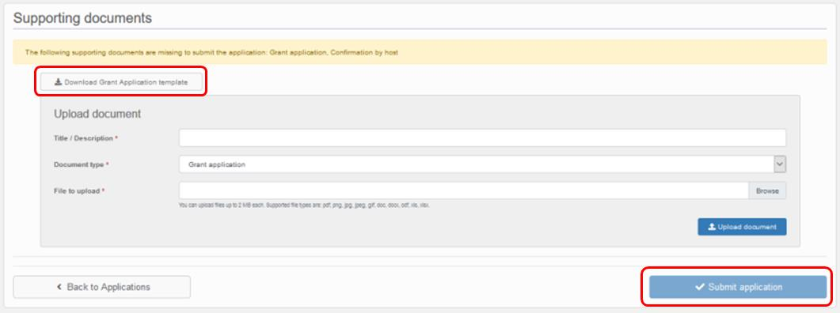
After adding the supporting document(s), the applicant can submit the grant application by clicking on “Submit application”.
The application status will change from “draft” to “submitted”. Prior to approval of the application, if requested by the Grant Manager, Action Chair/Co-chair or MC, the applicant will be able to revise the application in eCOST.

In the following pages, the templates for STSMs and VMGs applications are shown.

